Banana Cream Pie

Ingredients

GRAHAM CRACKER CRUST
- 1 3/4 cups fine graham cracker crumbs
- 1/2 teaspoon cinnamon
- Big pinch of salt
- 6 tablespoons melted butter
- 1 teaspoon water
- VANILLA PUDDING FILLING
- 3/4 cup plus 2 tablespoons sugar
- 1/4 cup plus 2 tablespoons cornstarch
- 1/8 teaspoon salt
- 3 cups milk or half and half
- 3 egg yolks
- 2 tablespoons butter, cut into pieces
- 2 teaspoons vanilla extract
- WHIPPED CREAM AND GARNISH
- 11/4 cups very cold heavy cream

Instructions
To Prepare the Piecrust: Heat the oven to 325º. Lightly butter a deep 9- or 10-inch pie pan. In a large mixing bowl, combine the graham cracker crumbs, cinnamon, and salt and mix the ingredients briefly with your fingers. Stir in the melted butter and water with a fork. Then use your fingers to rub together the mixture until the crumbs are uniformly moistened. | 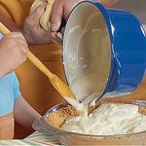
Empty the crumbs into the prepared pie pan. Press them evenly into the bottom and about three quarters of the way up the sides of the pan. Bake the piecrust on the center oven rack for 8 minutes, then cool it in the pan on a rack while you make the filling. | 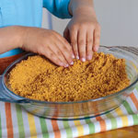
To Cook the Pudding Filling: Combine the sugar, cornstarch, and salt in a nonstick medium-size saucepan and whisk them until evenly blended. Then whisk in the milk and the egg yolks.
Heat the pudding over medium heat, stirring continuously until it thickens and bubbles, about 5 minutes. Continue cooking the mixture for 1 minute more, whisking all the while to keep it from boiling.
Remove the pan from the heat and whisk in the butter one piece at a time. Add the vanilla extract and whisk several more times. Immediately pour the filling into the piecrust, spreading and smoothing it with a wooden spoon. | 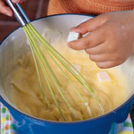
Gently press a piece of plastic wrap against the filling to keep a skin from forming. Put the pie on a cooling rack and cool to room temperature. Then chill it for at least 6 hours, or overnight | 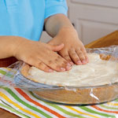
To make the Whipped Cream: Ten minutes before you're ready to assemble the pie, chill a mixing bowl and the beaters you'll use to make the whipped cream. Beat the heavy cream in the cold bowl until soft peaks form. Add the confectioners' sugar and continue to beat the whipped cream with a whisk until it is stiff but still smooth. Avoid overbeating it, or the cream will separate, much as it does when you churn butter.

Remove the plastic covering from the pie and use a rubber spatula to spread a thin layer of whipped cream over the pudding. Using a butter knife, quarter the bananas lengthwise, then cut them crosswise into small chunks, letting them fall over the pie in a single layer. | 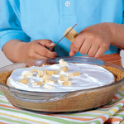
Mound the remaining whipped cream on top of the sliced bananas. Then garnish with shaved chocolate, if you like, and refrigerate the pie until serving time. Makes 8 to 10 servings.

